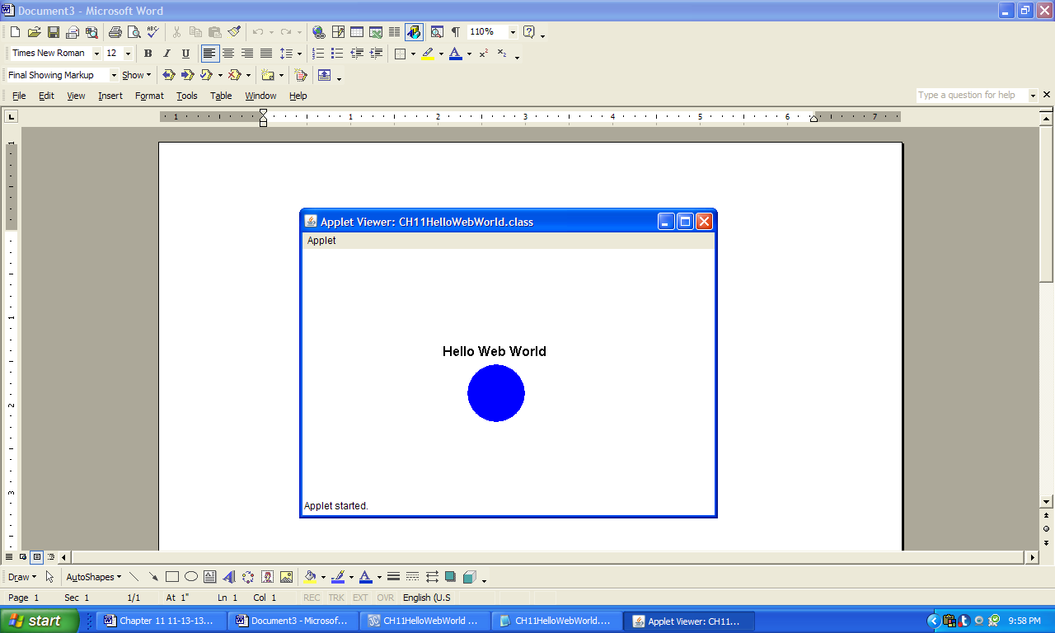

**Figure 11.42 The output produced by the applet CH11HelloWebWorld running in the applet viewer.**